ConceptVoice AI
Voice-Based Concept Understanding Analyzer
Project Design & Implementation Document

Skill Wallet — Technical Project Handbook
Prepared by: Senior Software Engineering & Technical Documentation Team

1. Title & Product Overview

Project Name
Voice-Based Concept Understanding Analyser

Project Description
The Voice-Based Concept Understanding Analyser is a single-page Streamlit application that lets a user record or upload a spoken explanation of a technical concept and receive an automated, multi-signal evaluation of how well they explained it. The app combines a locally run OpenAI Whisper model for transcription, a Sentence-BERT semantic-similarity check against a curated reference explanation for the chosen topic, Librosa-derived speech metrics (pause ratio, energy, filler-word rate), and a transparent, rule-based scoring formula to produce a 0–100 understanding score. An optional Google Gemini integration — enabled only if the user supplies their own Gemini API key in the sidebar for that session — can auto-detect the topic from the transcript and generate a short block of free-text coaching feedback. Every completed analysis is rendered as an in-app dashboard with a waveform image, is downloadable as a formatted PDF report, and is appended to a session-scoped attempt history the user can revisit from the sidebar.
The platform is built around six functional modules, each implemented as a small, focused Python module:
- Concept Transcriber (speech_to_text.py): Loads a local Whisper base model once at import time and transcribes recorded or uploaded audio in either English or Telugu (Beta), also computing a simple filler-word ratio from the resulting text.
- Semantic Similarity Evaluator (semantic_eval.py): Holds a fixed library of eight reference topics (Machine Learning, Cloud Computing, Deep Learning, Artificial Intelligence, Neural Networks, Data Science, Natural Language Processing, Computer Vision), each with a short expert-written reference paragraph, and uses Sentence-BERT (all-MiniLM-L6-v2) to compute a single cosine-similarity score between the user's transcript and the selected topic's reference text.
- Audio Feature Extractor (audio_utils.py): Uses Librosa to compute duration, RMS energy, zero-crossing rate, and a speech/pause ratio (via silence-interval splitting), and renders a Matplotlib waveform image returned as PNG bytes for display and inclusion in the PDF report.
- Rule-Based Scoring Engine (scoring_engine.py): Combines the semantic similarity score, filler-word ratio, pause ratio, and RMS energy into a weighted 0–100 understanding score with a three-tier classification (Strong / Moderate / Poor Understanding), plus a separate fluency sub-score derived from filler and pause ratios.
- Optional Gemini Add-ons (semantic_eval.py): Two independent, best-effort Gemini calls — auto_detect_topic(), which classifies the transcript into one of the eight fixed topics, and get_gemini_feedback(), which generates a short block of free-text coaching feedback — both gated behind a Gemini API key the user types into the sidebar for that session only.
- PDF Report Generator (report_generator.py): Uses ReportLab to assemble a formatted PDF containing the reference concept text, the full transcript, the waveform image, a metrics summary table, and the Gemini feedback (or a placeholder message if no key was supplied).
Together, these modules give a user immediate, multi-angle feedback on a spoken explanation — an objective similarity-to-reference score, concrete speech-delivery metrics, and an overall understanding rating — with optional LLM-generated coaching layered on top, all running as a single local Streamlit app.

Technology Stack (as implemented)
Layer | Technology | Purpose
UI + Application Logic | Streamlit | Single-script app (app.py) rendering the sidebar, recorder/uploader, and results dashboard, and orchestrating the full pipeline on each button click
Audio Recording Widget | audio-recorder-streamlit (audio_recorder()) | Renders an in-browser microphone recorder button and returns raw audio bytes
Speech-to-Text | OpenAI Whisper, local inference (whisper.load_model("base")) | Transcribes recorded/uploaded audio on-device in English or Telugu (Beta); model is loaded once at module import
Semantic Similarity | Sentence-BERT (sentence-transformers, all-MiniLM-L6-v2) | Computes a single cosine-similarity score between the transcript and a fixed reference paragraph for the selected topic
Audio Feature Extraction & Waveform | Librosa + Matplotlib | Computes duration, RMS energy, zero-crossing rate, and pause ratio; renders a waveform plot as PNG bytes
Scoring | Custom rule-based Python logic (scoring_engine.py) | Deterministic weighted formula (no LLM involved) producing the final 0-100 score, understanding level, and fluency sub-score
Optional Reasoning Add-ons | Google Gemini API (gemini-1.5-flash) | Best-effort topic auto-detection and free-text coaching feedback; only runs if the user supplies an API key in the sidebar
PDF Report Generation | ReportLab (SimpleDocTemplate, Platypus flowables) | Generates a downloadable PDF with the reference text, transcript, waveform image, metrics table, and feedback
Attempt History | Streamlit st.session_state (in-memory list) | Stores attempts for the current browser session only; not persisted to disk or a database, and is cleared on refresh/restart or via the sidebar "Clear History" button
NLP Utility | nltk (punkt tokenizer download) | Downloaded at import time in speech_to_text.py; available for future sentence-level processing
Deployment | Streamlit local (streamlit run app.py) | Runs the app on http://localhost:8501

Known Implementation Notes & Constraints
These are drawn directly from the current codebase and are worth documenting explicitly rather than glossing over:
- Topic list is fixed, not open-ended: CONCEPT_REFERENCES in semantic_eval.py hardcodes exactly eight topics. A user explaining a concept outside this list must either pick the closest match manually or rely on Gemini auto-detection, which still snaps to one of the same eight topics.
- Gemini key is entered per session, not loaded from .env: Although a .env.example file exists in the repository (GEMINI_API_KEY=your_gemini_api_key_here), the current app.py does not use python-dotenv — the key is collected via a sidebar st.text_input(type="password") and used only in memory for that session.
- Attempt history does not survive a restart: st.session_state.history is an in-memory Python list scoped to the active Streamlit session; there is no SQLite or file-based persistence, so history disappears on a full app restart or a new browser session.
- ffmpeg discovery includes a hardcoded personal path: get_ffmpeg_path() in speech_to_text.py falls back to a specific WinGet installation path on one developer's machine (C:\Users\sujth\...) before trying generic common paths — this should be treated as a portability issue to clean up before wider distribution.
- No explicit audio size/duration validation: unlike a hardened production pipeline, the current code does not reject overly long or oversized recordings before sending them to Whisper/Librosa; very long files will simply take longer to process.
- Scoring is deterministic and LLM-free: the 0-100 score itself is never produced by Gemini — it comes entirely from evaluate_understanding()'s fixed point thresholds, which makes the score reproducible and free of LLM cost, at the expense of the nuanced, per-gap reasoning an LLM-driven rubric could offer.

2. Scenarios
Scenario 1: A student opens the sidebar, leaves "Auto Detect Topic" unchecked, selects "Machine Learning" from the topic dropdown, and sees the built-in reference paragraph displayed in the right-hand column. They record a 45-second explanation using the microphone button under the "Live Record" tab. On clicking "Analyze Concept Understanding," the local Whisper model transcribes the recording, filler_word_ratio() finds a moderate number of filler words, extract_audio_features() reports a pause ratio of 0.18 and healthy RMS energy, and semantic_similarity() returns 0.74 against the Machine Learning reference paragraph. evaluate_understanding() combines these into a score of 85/100 and a "Strong Understanding" 🟢 classification, with a fluency score of 78/100. Because no Gemini key was entered, the feedback panel simply shows "Add Gemini API key for AI feedback." The attempt is appended to the sidebar's Attempt History list and a PDF report is available for download.
Scenario 2: A user enables "Auto Detect Topic (Gemini)" and pastes a Gemini API key into the sidebar, then uploads a pre-recorded .mp3 file explaining "Neural Networks" via the "Upload File" tab without selecting a topic manually. After transcription, auto_detect_topic() sends the transcript to gemini-1.5-flash, which classifies it as "Neural Networks" from the fixed eight-topic list; get_reference() then supplies the matching reference paragraph for the similarity check. The resulting similarity is only 0.41 (moderate topical overlap but imprecise phrasing), pushing the rule-based score to 52/100 — a "Moderate Understanding" 🟡 result. Because a Gemini key was supplied, get_gemini_feedback() also returns three to four sentences of free-text coaching (e.g., encouraging more precise terminology around activation functions), which is shown on screen and included in the downloaded PDF report.
Scenario 3: A user selects the Telugu (Beta) language option and records an explanation of "Cloud Computing" in Telugu. speech_to_text() passes language="te" into Whisper's transcribe() call; because the base English-tuned model has weaker multilingual accuracy, the resulting transcript is noisier than an equivalent English recording, which the UI flags with a standing sidebar warning ("Telugu support is in Beta"). The semantic similarity comparison still runs against the English-language Machine Learning-style reference paragraph library, so the similarity score is likely to be lower purely due to the cross-language comparison — an explicit, documented limitation of the current implementation rather than a bug, since there is no Telugu-language reference text or translation step in the pipeline yet.

3. Technical Architecture

3.1 Architecture Overview
Description: The application is a single-tier Streamlit script. app.py imports five sibling modules and calls them in sequence inside the "Analyze Concept Understanding" button handler, holding all intermediate state (transcript, features, score, history) in st.session_state for the duration of the browser session.
- UI Layer (app.py): Renders the sidebar (Gemini key input, auto-detect checkbox, topic dropdown, language radio, attempt history, reset/clear buttons), the two-column main area (recorder/uploader tabs on the left, reference text on the right), the Analyze button, and the results section (transcript, score, metrics, waveform image, PDF download).
- Recording Layer (audio_recorder_streamlit): A third-party Streamlit component providing the audio_recorder() widget used under the "Live Record" tab; returns raw WAV bytes directly from the browser microphone.
- Transcription Layer (speech_to_text.py): Loads a local Whisper base model once at import time; speech_to_text() transcribes a given audio file path in English or Telugu and returns a success/error dict; filler_word_ratio() scans the resulting text for a fixed list of filler words.
- Audio Feature Layer (audio_utils.py): extract_audio_features() decodes the audio with Librosa and computes duration, RMS energy, zero-crossing rate, and pause ratio; save_waveform() renders a dark-themed Matplotlib waveform plot and returns it as PNG bytes.
- Semantic Evaluation Layer (semantic_eval.py): Holds the CONCEPT_REFERENCES dictionary of eight topics; semantic_similarity() embeds both the transcript and the reference text with Sentence-BERT and returns their cosine similarity; auto_detect_topic() and get_gemini_feedback() are optional Gemini-backed helpers gated on an API key being supplied.
- Scoring Layer (scoring_engine.py): evaluate_understanding() applies a fixed point-based formula to similarity, filler ratio, pause ratio, and RMS energy to produce the final score, level, and display color; calculate_fluency_score() derives a separate 0-100 fluency metric from filler and pause ratios; get_score_emoji() maps a level string to a colored circle emoji.
- Reporting Layer (report_generator.py): generate_pdf_report() assembles a ReportLab SimpleDocTemplate document (title, date/topic, reference text, transcript, waveform image, metrics table, Gemini feedback) and returns the PDF as bytes for st.download_button.

3.2 Processing Flow (as implemented)
Streamlit UI
|-- audio_recorder() [Live Record tab] --or-- st.file_uploader() [Upload File tab]
|
v
Save audio to a NamedTemporaryFile (.wav or .mp3)
|
v
speech_to_text(audio_path, lang_code) -----> Whisper (local, base model)
| |
| {success, text, language, segments}
v
filler_word_ratio(transcript) -----> filler ratio (float)
|
v
extract_audio_features(audio_path) -----> Librosa: duration, rms_energy,
| zero_crossing_rate, pause_ratio
v
save_waveform(audio_path) -----> Matplotlib PNG bytes
|
v
[if auto_detect + Gemini key] auto_detect_topic(transcript, api_key) -----> topic string
|
v
get_reference(topic) -----> fixed reference paragraph
|
v
semantic_similarity(transcript, ref_text) -----> Sentence-BERT cosine similarity
|
v
evaluate_understanding(similarity, filler, audio_features) -----> (score, level, color)
calculate_fluency_score(filler, pause_ratio) -----> fluency dict
|
v
[if Gemini key present] get_gemini_feedback(transcript, topic, score, api_key) -----> feedback text
|
v
st.session_state.history.append(...) + st.session_state.result = {...}
|
v
Streamlit renders: transcript, score card, metrics, waveform image
|
v
generate_pdf_report(...) -----> ReportLab PDF bytes -----> st.download_button

3.3 Component Responsibilities
Component | File | Key Functions
app.py | App root | Page config, sidebar, tabs, Analyze button handler, results rendering
speech_to_text.py | Module | get_ffmpeg_path(), speech_to_text(), get_word_count(), get_speaking_rate(), filler_word_ratio()
semantic_eval.py | Module | CONCEPT_REFERENCES, semantic_similarity(), auto_detect_topic(), get_gemini_feedback(), get_reference()
audio_utils.py | Module | extract_audio_features(), save_waveform()
scoring_engine.py | Module | evaluate_understanding(), get_score_emoji(), calculate_fluency_score()
report_generator.py | Module | generate_pdf_report()

3.4 In-Memory Data Shape (Attempt Result)
There is no database schema in the current implementation — each attempt is a plain Python dict held in st.session_state.result and appended (nested under a summary dict) to st.session_state.history. This is the shape actually produced by app.py:
{
"transcript": "string",
"topic": "Machine Learning",
"ref_text": "string (reference paragraph for the topic)",
"similarity": 0.74,
"filler": 0.045,
"audio_features": {
"success": true,
"duration": 46.2,
"rms_energy": 0.0312,
"zero_crossing_rate": 0.081,
"pause_ratio": 0.18,
"speech_duration": 37.9,
"pause_duration": 8.3
},
"score": 85,
"level": "Strong Understanding",
"color": "#2ecc71",
"emoji": "🟢",
"fluency": {"fluency_score": 78.0, "fluency_level": "Fluent"},
"feedback": "Add Gemini API key for AI feedback.",
"waveform_bytes": "<PNG bytes>"
}

Persistence caveat: because this structure lives only in st.session_state, it is lost whenever the Streamlit process restarts or the browser session ends. Section 6 (Future Scope) proposes an SQLite-backed history table as a natural upgrade path that would not require changing this in-memory shape, only adding a save/load layer around it.

4. Pre-requisites
- Streamlit Framework Knowledge: Streamlit Documentation (docs.streamlit.io)
- audio-recorder-streamlit component: PyPI project page (pypi.org/project/audio-recorder-streamlit)
- OpenAI Whisper (local) Familiarity: Whisper GitHub Repository (github.com/openai/whisper)
- Sentence-Transformers (Sentence-BERT): sentence-transformers Documentation (sbert.net)
- Google Gemini API Familiarity (optional feature): Google AI Studio / Gemini API Documentation (ai.google.dev/docs)
- Librosa for Audio Processing: Librosa Documentation (librosa.org/doc)
- ffmpeg (required by Whisper for audio decoding): FFmpeg Documentation (ffmpeg.org)
- ReportLab for PDF Generation: ReportLab User Guide (docs.reportlab.com)
- NLTK (punkt tokenizer): NLTK Documentation (nltk.org)
- Python Programming Proficiency: Python Documentation (docs.python.org)
- Version Control with Git: Git Documentation (git-scm.com/doc)
- PyTorch (Whisper + Sentence-BERT dependency): PyTorch Documentation (pytorch.org/docs)

5. Project Workflow & Milestones

Milestone 1: Model Selection and Environment Setup
This milestone covers selecting the local Whisper model and Sentence-BERT model actually used in the codebase, and setting up the environment needed to run app.py.
Activity 1.1: (Optional) Obtain a Gemini API Key
Because the current implementation collects the Gemini key directly through the Streamlit sidebar rather than from a .env file, this step is optional and per-session — a user can run the entire app, including transcription, scoring, waveform, and PDF export, without ever entering a Gemini key. The key is only needed to unlock the two optional Gemini features (topic auto-detection and free-text feedback).
- Step 1: Visit aistudio.google.com and sign in with a Google account.
- Step 2: Click "Get API key," then "Create API key," choosing a new or existing Google Cloud project.
- Step 3: Copy the generated key.
- Step 4: Paste it into the "Gemini API Key" password field in the app's sidebar at runtime — it is held only in that session's Streamlit state and is never written to disk by the current code.
A .env.example file is included in the repository for future use (see Section 3, Known Implementation Notes), but the current app.py does not load it — GEMINI_API_KEY is not read from the environment anywhere in the codebase today.
GEMINI_API_KEY=your_gemini_api_key_here

Activity 1.2: Model Selection (as implemented)
- Whisper model: whisper.load_model("base") is called once at the top of speech_to_text.py, outside any function, so it loads a single time when the module is first imported and is reused for every transcription for the life of the process.
- Sentence-BERT model: SentenceTransformer('all-MiniLM-L6-v2') is likewise instantiated once at the top of semantic_eval.py.
- Gemini model: genai.GenerativeModel('gemini-1.5-flash') is created fresh inside both auto_detect_topic() and get_gemini_feedback() each time they are called, using whatever API key was passed in from the sidebar for that call.
Activity 1.3: Set Up the Development Environment
D:\projects>python -m venv myenv
D:\projects>"d:\projects\venv\Scripts\activate"
(myenv) D:\projects> pip install -r requirements.txt

requirements.txt (as committed in the repository):
streamlit
openai-whisper
sentence-transformers
librosa
soundfile
numpy
matplotlib
reportlab
torch
nltk
google-generativeai
audio-recorder-streamlit

Note: the requirements file does not pin exact versions. For a reproducible environment, freeze the working set after a successful local install with pip freeze > requirements.lock.txt and commit that alongside the loose requirements.txt.
Install ffmpeg (required by Whisper for audio decoding): download the official build on Windows and add it to PATH, brew install ffmpeg on macOS, or apt-get install ffmpeg on Linux. speech_to_text.py's get_ffmpeg_path() will also try to auto-discover it (see Milestone 2, Activity 2.1).
Project Structure (matches the GitHub repository layout):
5. Project Development Phase/
app.py
speech_to_text.py
semantic_eval.py
audio_utils.py
scoring_engine.py
report_generator.py
requirements.txt
.env.example
6. Project Testing/
test_functional.py
test_performance.py

Milestone 2: Core Module Implementation (as built)
Activity 2.1: Concept Transcription and Filler Detection (speech_to_text.py)
This module locates ffmpeg, loads the local Whisper base model once, and exposes transcription plus a few simple text-metric helpers.
import whisper
import nltk
import os
import shutil

nltk.download('punkt', quiet=True)

def get_ffmpeg_path():
"""Find and return ffmpeg executable path"""
ffmpeg = shutil.which("ffmpeg")
if ffmpeg:
print("Found ffmpeg in system PATH")
return ffmpeg

# Developer-specific WinGet path (portability issue - see Section 3)
specific_path = r"C:\Users\sujth\AppData\Local\Microsoft\WinGet\Packages\Gyan.FFmpeg_Microsoft.Winget.Source_8wekyb3d8bbwe\ffmpeg-8.1.2-full_build\bin\ffmpeg.exe"
if os.path.exists(specific_path):
print("Using ffmpeg from WinGet location")
return specific_path

common_paths = [
r"C:\ffmpeg\bin\ffmpeg.exe",
r"C:\Program Files\ffmpeg\bin\ffmpeg.exe",
]
for path in common_paths:
if os.path.exists(path):
print(f"Found ffmpeg at: {path}")
return path

print("ffmpeg not found! Please install ffmpeg.")
return None

# Load Whisper model once, at import time
model = whisper.load_model("base")

def speech_to_text(audio_path: str, language: str = "en") -> dict:
try:
ffmpeg_path = get_ffmpeg_path()
if ffmpeg_path:
os.environ["PATH"] = os.path.dirname(ffmpeg_path) + os.pathsep + os.environ.get("PATH", "")
os.environ["IMAGEIO_FFMPEG_EXE"] = ffmpeg_path

if not os.path.exists(audio_path):
return {"success": False, "error": f"Audio file not found: {audio_path}"}

if language == "te":
result = model.transcribe(audio_path, language="te", task="transcribe")
else:
result = model.transcribe(audio_path, language="en", task="transcribe")

return {
"success": True,
"text": result["text"].strip(),
"language": language,
"segments": result.get("segments", [])
}

except Exception as e:
return {"success": False, "error": str(e)}

def get_word_count(text: str) -> int:
return len(text.split())

def get_speaking_rate(text: str, duration_seconds: float) -> float:
words = get_word_count(text)
minutes = duration_seconds / 60
return round(words / minutes, 2) if minutes > 0 else 0

def filler_word_ratio(text: str) -> float:
fillers = ["um", "uh", "like", "you know", "basically", "actually", "literally", "so", "right", "okay"]
words = text.lower().split()
total = len(words)
filler_count = sum(1 for word in words if word in fillers)
return round(filler_count / total, 4) if total > 0 else 0

Activity 2.2: Semantic Similarity and Optional Gemini Add-ons (semantic_eval.py)
from sentence_transformers import SentenceTransformer, util
import google.generativeai as genai

model = SentenceTransformer('all-MiniLM-L6-v2')

CONCEPT_REFERENCES = {
"Machine Learning": """Machine learning is a subset of artificial intelligence
that enables systems to learn and improve from experience without being explicitly
programmed. It focuses on developing computer programs that can access data and
use it to learn for themselves.""",

"Cloud Computing": """Cloud computing is the delivery of computing services
including servers, storage, databases, networking, software, analytics and
intelligence over the internet to offer faster innovation, flexible resources
and economies of scale.""",

"Deep Learning": """Deep learning is a subset of machine learning that uses
neural networks with many layers to learn representations of data with multiple
levels of abstraction.""",

"Artificial Intelligence": """Artificial intelligence is the simulation of
human intelligence processes by machines, especially computer systems, including
learning, reasoning, problem solving, perception and language understanding.""",

"Neural Networks": """Neural networks are computing systems inspired by biological
neural networks consisting of interconnected nodes that process information using
connectionist approaches to computation.""",

"Data Science": """Data science is an interdisciplinary field that uses scientific
methods, processes, algorithms and systems to extract knowledge and insights
from structured and unstructured data.""",

"Natural Language Processing": """Natural language processing is a branch of
artificial intelligence that helps computers understand, interpret and manipulate
human language bridging the gap between human communication and computer understanding.""",

"Computer Vision": """Computer vision is a field of artificial intelligence that
trains computers to interpret and understand the visual world using digital images
and deep learning models to accurately identify and classify objects."""
}

def semantic_similarity(text1: str, text2: str) -> float:
embeddings = model.encode([text1, text2], convert_to_tensor=True)
similarity = util.cos_sim(embeddings[0], embeddings[1])
return round(float(similarity), 4)

def auto_detect_topic(text: str, api_key: str) -> str:
try:
genai.configure(api_key=api_key)
gemini = genai.GenerativeModel('gemini-1.5-flash')
topics = list(CONCEPT_REFERENCES.keys())
prompt = f"""Given this spoken explanation: "{text}"
Which topic from this list best matches?
Topics: {', '.join(topics)}
Reply with ONLY the topic name."""
response = gemini.generate_content(prompt)
detected = response.text.strip()
return detected if detected in CONCEPT_REFERENCES else topics[0]
except:
return "Machine Learning"

def get_gemini_feedback(text: str, topic: str, score: float, api_key: str) -> str:
try:
genai.configure(api_key=api_key)
gemini = genai.GenerativeModel('gemini-1.5-flash')
prompt = f"""A student explained "{topic}" and got score {score}/100.
Their explanation: "{text}"
Give 3-4 lines of friendly feedback on what they did well and what to improve."""
response = gemini.generate_content(prompt)
return response.text.strip()
except Exception as e:
return f"Could not generate feedback: {str(e)}"

def get_reference(topic: str) -> str:
return CONCEPT_REFERENCES.get(topic, "Topic not found")

Note on error handling: auto_detect_topic() uses a bare except: clause that silently falls back to "Machine Learning" on any failure (invalid key, network error, unexpected response format). This is convenient for a demo but means a bad Gemini key produces a silently wrong topic rather than a visible error — flagged further in Section 8 (Security Considerations).
Activity 2.3: Audio Feature Extraction and Waveform Rendering (audio_utils.py)
import librosa
import numpy as np
import soundfile as sf
import matplotlib.pyplot as plt
import io

def extract_audio_features(audio_path: str) -> dict:
try:
y, sr = librosa.load(audio_path, sr=None)
duration = librosa.get_duration(y=y, sr=sr)
rms_energy = float(np.mean(librosa.feature.rms(y=y)))
zero_crossing = float(np.mean(librosa.feature.zero_crossing_rate(y=y)))

intervals = librosa.effects.split(y, top_db=30)
speech_duration = sum([(e - s) / sr for s, e in intervals])
pause_duration = duration - speech_duration
pause_ratio = round(pause_duration / duration, 4) if duration > 0 else 0

return {
"success": True,
"duration": round(duration, 2),
"rms_energy": round(rms_energy, 4),
"zero_crossing_rate": round(zero_crossing, 4),
"pause_ratio": pause_ratio,
"speech_duration": round(speech_duration, 2),
"pause_duration": round(pause_duration, 2),
}
except Exception as e:
return {"success": False, "error": str(e)}

def save_waveform(audio_path: str) -> bytes:
try:
y, sr = librosa.load(audio_path, sr=None)
fig, ax = plt.subplots(figsize=(10, 3))
times = np.linspace(0, len(y) / sr, len(y))
ax.plot(times, y, color='#00b4d8', linewidth=0.5)
ax.set_xlabel("Time")
ax.set_ylabel("Amplitude")
ax.set_title("Audio Waveform")
ax.set_facecolor("#0d1117")
fig.patch.set_facecolor("#0d1117")
ax.tick_params(colors='white')
ax.xaxis.label.set_color('white')
ax.yaxis.label.set_color('white')
ax.title.set_color('white')
buf = io.BytesIO()
plt.savefig(buf, format='png', bbox_inches='tight',
facecolor=fig.get_facecolor())
plt.close()
buf.seek(0)
return buf.getvalue()
except Exception as e:
return None

Note: save_waveform() re-loads the audio file from disk with Librosa independently of extract_audio_features(), rather than reusing an already-decoded signal — a straightforward efficiency improvement would be to decode once and pass the signal into both functions (see Section 6, Future Scope).
Activity 2.4: Rule-Based Scoring Engine (scoring_engine.py)
def evaluate_understanding(similarity: float, filler_ratio: float, audio: dict) -> tuple:
score = 0

# Semantic similarity score (50 points max)
score += 50 if similarity > 0.7 else 30 if similarity > 0.4 else 10

# Filler word score (20 points max)
score += 20 if filler_ratio < 0.05 else 10

# Pause ratio score (15 points max)
score += 15 if audio["pause_ratio"] < 0.25 else 5

# RMS energy score (15 points max)
score += 15 if audio["rms_energy"] > 0.01 else 5

# Classification
if score >= 80:
return score, "Strong Understanding", "#2ecc71"
elif score >= 50:
return score, "Moderate Understanding", "#f39c12"
else:
return score, "Poor Understanding", "#e74c3c"

def get_score_emoji(level: str) -> str:
if level == "Strong Understanding":
return "🟢"
elif level == "Moderate Understanding":
return "🟡"
else:
return "🔴"

def calculate_fluency_score(filler_ratio: float, pause_ratio: float) -> dict:
fluency = 100
fluency -= (filler_ratio * 200)
fluency -= (pause_ratio * 100)
fluency = max(0, min(100, round(fluency, 2)))

if fluency >= 75:
level = "Fluent"
elif fluency >= 50:
level = "Moderate"
else:
level = "Needs Improvement"

return {
"fluency_score": fluency,
"fluency_level": level
}

Scoring transparency: because every threshold here is a fixed Python constant (0.7, 0.4, 0.05, 0.25, 0.01, 80, 50), the entire scoring model is fully auditable and reproducible — the same transcript and audio metrics will always yield the same score. This is a deliberate trade-off against the more adaptive, per-gap reasoning an LLM-based rubric could provide.

Milestone 3: Application Orchestration (app.py)
Milestone 3 covers app.py itself — the single Streamlit script that wires together every module from Milestone 2, manages session state, and renders the sidebar and results UI. The code below is reproduced from the repository as committed.
Activity 3.1: Page Setup, Styling, and Session State
import streamlit as st
import tempfile
import os
from audio_recorder_streamlit import audio_recorder

# Your custom modules
from speech_to_text import speech_to_text, filler_word_ratio
from semantic_eval import semantic_similarity, auto_detect_topic, get_gemini_feedback, get_reference, CONCEPT_REFERENCES
from audio_utils import extract_audio_features, save_waveform
from scoring_engine import evaluate_understanding, get_score_emoji, calculate_fluency_score
from report_generator import generate_pdf_report

st.set_page_config(
page_title="Voice-Based Concept Understanding Analyser",
page_icon="\U0001F3A4",
layout="wide"
)

# Custom Styling
st.markdown("""
<style>
.main { background-color: #0d1117; color: white; }
h1, h2, h3 { color: white; }
.metric-card {
background-color: #1a1a2e;
padding: 15px;
border-radius: 10px;
margin: 5px;
text-align: center;
}
.score-card {
background-color: #16213e;
padding: 20px;
border-radius: 15px;
text-align: center;
margin: 10px 0;
}
</style>
""", unsafe_allow_html=True)

st.title("Voice-Based Concept Understanding Analyser")
st.markdown("**Automated evaluation of spoken conceptual explanations using AI**")
st.markdown("---")

# Session State
if "history" not in st.session_state:
st.session_state.history = []
if "result" not in st.session_state:
st.session_state.result = None
if "recorded_path" not in st.session_state:
st.session_state.recorded_path = None

Activity 3.2: Sidebar — Settings, Topic Selection, and History
with st.sidebar:
st.header("Settings")
gemini_api_key = st.text_input("Gemini API Key", type="password")
auto_detect = st.checkbox("Auto Detect Topic (Gemini)", value=False)

if not auto_detect:
topic = st.selectbox("Select Concept Topic", list(CONCEPT_REFERENCES.keys()))
else:
topic = "Machine Learning" # fallback

language = st.radio("Language", ["English", "Telugu (Beta)"])
lang_code = "te" if "Telugu" in language else "en"

if "Telugu" in language:
st.warning("Telugu support is in Beta")

st.markdown("---")
st.markdown("### Attempt History")
if st.session_state.history:
for i, h in enumerate(st.session_state.history[-5:]):
if st.button(f"Attempt {i+1}: {h['topic']} -> {h['score']}/100", key=f"hist_{i}"):
st.session_state.result = h['result']
st.rerun()
else:
st.info("No attempts yet!")
st.markdown("---")
if st.button("Reset / New Analysis"):
st.session_state.result = None
st.session_state.recorded_path = None
st.rerun()
if st.button("Clear History"):
st.session_state.history = []
st.rerun()

Note: the last five attempts are shown as clickable sidebar buttons ([-5:] slice); clicking one restores that attempt's result dict into st.session_state.result without re-running any analysis, since the full result was cached at the time of the original attempt.
Activity 3.3: Main Area — Recorder, Uploader, and Reference Panel
col1, col2 = st.columns([1.5, 1])

audio_file = None

with col1:
st.subheader("Record or Upload Audio")
tab1, tab2 = st.tabs(["Live Record", "Upload File"])

with tab1:
audio_bytes = audio_recorder()
if audio_bytes:
st.audio(audio_bytes, format="audio/wav")
with tempfile.NamedTemporaryFile(delete=False, suffix=".wav") as f:
f.write(audio_bytes)
st.session_state.recorded_path = f.name

with tab2:
audio_file = st.file_uploader("Upload audio (WAV/MP3)", type=["wav", "mp3"])

with col2:
if not auto_detect:
st.subheader("Concept Reference")
ref_text = get_reference(topic)
st.info(ref_text)

Activity 3.4: Analyze Button — Full Pipeline Orchestration
if st.button("Analyze Concept Understanding", type="primary"):
with st.spinner("Transcribing and evaluating..."):
audio_path = None
try:
# Get valid audio path
if st.session_state.recorded_path and os.path.exists(st.session_state.recorded_path):
audio_path = st.session_state.recorded_path
elif audio_file:
suffix = ".wav" if audio_file.type == "audio/wav" else ".mp3"
with tempfile.NamedTemporaryFile(delete=False, suffix=suffix) as tmp:
tmp.write(audio_file.getvalue())
audio_path = tmp.name
else:
st.error("Please record or upload an audio file.")
st.stop()

transcript_result = speech_to_text(audio_path, lang_code)

if not transcript_result.get("success"):
st.error(f"Transcription failed: {transcript_result.get('error', 'Unknown error')}")
else:
transcript = transcript_result["text"]
filler = filler_word_ratio(transcript)
audio_features = extract_audio_features(audio_path)
waveform_bytes = save_waveform(audio_path)

# Auto-detect topic
current_topic = topic
if auto_detect and gemini_api_key:
current_topic = auto_detect_topic(transcript, gemini_api_key)

ref_text = get_reference(current_topic)
similarity = semantic_similarity(transcript, ref_text)

score, level, color = evaluate_understanding(similarity, filler, audio_features)
fluency = calculate_fluency_score(filler, audio_features.get("pause_ratio", 0))
emoji = get_score_emoji(level)

feedback = get_gemini_feedback(transcript, current_topic, score, gemini_api_key) if gemini_api_key else "Add Gemini API key for AI feedback."

st.session_state.history.append({
"topic": topic,
"score": score,
"level": level,
"result": {
"transcript": transcript,
"topic": topic,
"ref_text": ref_text,
"similarity": similarity,
"filler": filler,
"audio_features": audio_features,
"score": score,
"level": level,
"color": color,
"emoji": emoji,
"fluency": fluency,
"feedback": feedback,
"waveform_bytes": waveform_bytes
}
})

st.session_state.result = {
"transcript": transcript,
"topic": current_topic,
"ref_text": ref_text,
"similarity": similarity,
"filler": filler,
"audio_features": audio_features,
"score": score,
"level": level,
"color": color,
"emoji": emoji,
"fluency": fluency,
"feedback": feedback,
"waveform_bytes": waveform_bytes
}
st.success("Analysis Completed!")

except Exception as e:
st.error(f"Error: {str(e)}")
finally:
# Cleanup uploaded files only
if audio_path and audio_path != st.session_state.get("recorded_path"):
if os.path.exists(audio_path):
try:
os.unlink(audio_path)
except:
pass

Note on the topic mismatch: when auto_detect is enabled, the code stores the originally selected sidebar topic (topic) into st.session_state.history, but stores the Gemini-detected topic (current_topic) into st.session_state.result. This is a real inconsistency worth fixing (see Section 6, Future Scope) — the sidebar history label and the live result panel can show two different topic names for the same attempt when auto-detection changes the topic.
Note on temp-file cleanup: the finally block only deletes the temporary file if it came from the uploader path (audio_path != recorded_path); a live-recorded temp file (recorded_path) is deliberately left on disk so the sidebar's "Attempt History" buttons can still reference it later in the session, but this means recorded .wav temp files accumulate in the OS temp directory for the life of the process (see Section 8, Security Considerations).
Activity 3.5: Results Rendering
if st.session_state.result:
r = st.session_state.result
st.markdown("---")
st.subheader("Analysis Results")

col_a, col_b = st.columns(2)
with col_a:
st.markdown("**Transcribed Explanation**")
st.write(r["transcript"])

with col_b:
st.markdown("**Final Score**")
st.markdown(f"<h1 style='color:{r['color']}; text-align:center;'>{r['score']}/100</h1>", unsafe_allow_html=True)
st.markdown(f"<h3 style='text-align:center;'>{r['emoji']} {r['level']}</h3>", unsafe_allow_html=True)

# Metrics
col1, col2, col3 = st.columns(3)
with col1:
st.metric("Semantic Similarity", r["similarity"])
with col2:
st.metric("Filler Words", r["filler"])
with col3:
st.metric("Fluency Score", f"{r['fluency']['fluency_score']}/100")

if r.get("waveform_bytes"):
st.image(r["waveform_bytes"], use_column_width=True)

# PDF Download
pdf_bytes = generate_pdf_report(
topic=r['topic'],
reference_text=r['ref_text'],
transcribed_text=r['transcript'],
similarity=r['similarity'],
filler_ratio=r['filler'],
pause_ratio=r['audio_features'].get('pause_ratio', 0),
rms_energy=r['audio_features'].get('rms_energy', 0),
final_score=r['score'],
understanding_level=r['level'],
fluency_score=r['fluency']['fluency_score'],
gemini_feedback=r['feedback'],
waveform_bytes=r['waveform_bytes']
)

st.download_button(
label="Download Full PDF Report",
data=pdf_bytes,
file_name=f"VBCUA_Report_{r['topic'].replace(' ', '_')}.pdf",
mime="application/pdf"
)

# Clear button
if st.button("Clear Results"):
st.session_state.result = None
st.rerun()

Milestone 4: PDF Report Generation (report_generator.py)
Milestone 4 covers the ReportLab-based PDF export, which assembles the reference text, transcript, waveform image, a metrics summary table, and the Gemini feedback (or its placeholder) into a single downloadable document.
from reportlab.lib.pagesizes import letter
from reportlab.lib import colors
from reportlab.lib.styles import getSampleStyleSheet, ParagraphStyle
from reportlab.platypus import SimpleDocTemplate, Paragraph, Spacer, Table, TableStyle, Image
from reportlab.lib.units import inch
import io
from datetime import datetime

def generate_pdf_report(
topic: str,
reference_text: str,
transcribed_text: str,
similarity: float,
filler_ratio: float,
pause_ratio: float,
rms_energy: float,
final_score: int,
understanding_level: str,
fluency_score: float,
gemini_feedback: str,
waveform_bytes: bytes = None
) -> bytes:
buffer = io.BytesIO()
doc = SimpleDocTemplate(buffer, pagesize=letter,
rightMargin=72, leftMargin=72,
topMargin=72, bottomMargin=72)
styles = getSampleStyleSheet()
story = []

# Title
title_style = ParagraphStyle(
'CustomTitle',
parent=styles['Heading1'],
fontSize=20,
textColor=colors.HexColor('#1a1a2e'),
spaceAfter=10,
alignment=1
)
story.append(Paragraph("Voice-Based Concept Understanding Analyser", title_style))
story.append(Paragraph("Evaluation Report", title_style))
story.append(Spacer(1, 0.2 * inch))

# Date and topic
info_style = ParagraphStyle('Info', parent=styles['Normal'], fontSize=11)
story.append(Paragraph(f"<b>Date:</b> {datetime.now().strftime('%d %B %Y %I:%M %p')}", info_style))
story.append(Paragraph(f"<b>Topic Evaluated:</b> {topic}", info_style))
story.append(Spacer(1, 0.2 * inch))

# Reference concept
story.append(Paragraph("Reference Concept", styles['Heading2']))
story.append(Paragraph(reference_text.strip(), styles['Normal']))
story.append(Spacer(1, 0.2 * inch))

# Student transcription
story.append(Paragraph("Student Transcription", styles['Heading2']))
story.append(Paragraph(transcribed_text.strip(), styles['Normal']))
story.append(Spacer(1, 0.2 * inch))

# Waveform image
if waveform_bytes:
story.append(Paragraph("Audio Visualization", styles['Heading2']))
img = Image(io.BytesIO(waveform_bytes), width=6 * inch, height=2 * inch)
story.append(img)
story.append(Spacer(1, 0.2 * inch))

# Evaluation summary table
story.append(Paragraph("Evaluation Summary", styles['Heading2']))
table_data = [
["Metric", "Value"],
["Semantic Similarity", str(similarity)],
["Filler Word Ratio", str(filler_ratio)],
["Pause Ratio", str(pause_ratio)],
["Confidence (Energy)", str(rms_energy)],
["Fluency Score", f"{fluency_score}/100"],
["Final Score", f"{final_score}/100"],
["Understanding Level", understanding_level],
]
table = Table(table_data, colWidths=[3 * inch, 3 * inch])
table.setStyle(TableStyle([
('BACKGROUND', (0, 0), (-1, 0), colors.HexColor('#1a1a2e')),
('TEXTCOLOR', (0, 0), (-1, 0), colors.white),
('FONTNAME', (0, 0), (-1, 0), 'Helvetica-Bold'),
('FONTSIZE', (0, 0), (-1, -1), 11),
('ROWBACKGROUNDS', (0, 1), (-1, -1), [colors.white, colors.HexColor('#f0f0f0')]),
('GRID', (0, 0), (-1, -1), 0.5, colors.grey),
('PADDING', (0, 0), (-1, -1), 8),
]))
story.append(table)
story.append(Spacer(1, 0.2 * inch))

# Gemini feedback
story.append(Paragraph("AI Feedback", styles['Heading2']))
story.append(Paragraph(gemini_feedback, styles['Normal']))
story.append(Spacer(1, 0.2 * inch))

doc.build(story)
buffer.seek(0)
return buffer.getvalue()

Milestone 5: Deployment (Streamlit Local)
The application is run locally via Streamlit's built-in development server. There is no Flask/Gunicorn layer, no Ngrok tunnel, and no containerization in the current repository — deployment is simply running the script.
Activity 5.1: Prepare the Environment
D:\projects>python -m venv myenv
D:\projects>"d:\projects\venv\Scripts\activate"
(myenv) D:\projects>pip install -r requirements.txt

Ensure ffmpeg is discoverable: either install it and add it to the system PATH so shutil.which("ffmpeg") in get_ffmpeg_path() finds it directly, or be aware that the code will otherwise fall back to a hardcoded developer-specific path that will not exist on other machines (see Section 3 and Section 8).
Activity 5.2: Run the App
(myenv) D:\projects>cd "5. Project Development Phase"
(myenv) D:\projects\5. Project Development Phase>streamlit run app.py

Streamlit starts its local development server and opens the app in the default browser:
Local URL: http://localhost:8501
Network URL: http://192.168.x.x:8501

The first run will download the local Whisper base model (~140MB) and the Sentence-BERT all-MiniLM-L6-v2 model (~80MB) to the default Hugging Face / Whisper cache directories; subsequent runs load from cache.
Activity 5.3: Local Testing and Verification
Test Case | Expected Result (as implemented)
Record a clear explanation, topic selected manually, no Gemini key | Full results render; feedback shows "Add Gemini API key for AI feedback."
Same, with a valid Gemini key and Auto Detect Topic checked | Topic is inferred from the transcript and matched against the fixed CONCEPT_REFERENCES list; free-text feedback appears
Upload a .mp3 file instead of recording | audio_file.type branch selects the .mp3 suffix and transcription proceeds identically
Select Telugu (Beta) and record in Telugu | speech_to_text() is called with language="te"; sidebar warning is shown; similarity is still computed against the English reference paragraph
Click Analyze with neither a recording nor an upload present | st.error("Please record or upload an audio file.") and st.stop() halt the handler
Enter an invalid Gemini API key with Auto Detect Topic checked | auto_detect_topic()'s bare except swallows the error and silently falls back to "Machine Learning" rather than surfacing a message
Click a past attempt in the sidebar Attempt History | st.session_state.result is restored from history without re-running transcription or scoring
Click "Clear History" | st.session_state.history is emptied; the currently displayed result (if any) is unaffected
Restart the Streamlit process | Attempt History is empty again, since it was only ever held in st.session_state

Important Notes
- There is no public URL, Ngrok tunnel, or reverse proxy involved — the app is reachable only at http://localhost:8501 (and the printed Network URL, for other devices on the same LAN).
- Because Whisper's base model and Sentence-BERT's all-MiniLM-L6-v2 are both loaded once at module import time (not behind a Streamlit cache decorator), Streamlit's script-rerun model means these imports only execute on the very first script run per process, not per interaction — subsequent reruns reuse the already-imported module-level model objects.
- The get_ffmpeg_path() hardcoded fallback path should be removed or replaced with an environment-variable-driven path before this app is shared with or run by anyone other than the original developer (see Section 8).

Milestone 6: Conclusion & Future Scope
The Voice-Based Concept Understanding Analyser, as implemented, delivers a working end-to-end pipeline: local Whisper transcription, Sentence-BERT semantic similarity against a curated reference library, Librosa-derived speech-delivery metrics, a transparent rule-based scoring formula, an optional Gemini-powered coaching layer, a downloadable ReportLab PDF, and a session-scoped attempt history — all inside a single Streamlit script with no external server dependency. It successfully demonstrates the core product idea ("explain a concept out loud and get scored feedback") without requiring any paid API key for its core functionality, since Gemini is strictly additive.
At the same time, reviewing the implementation surfaces a clear, concrete list of near-term improvements, several of which are minor code fixes rather than new features:
- Fix the topic-mismatch bug: store the same topic value (current_topic, not the original sidebar topic) in both st.session_state.history and st.session_state.result so the sidebar history label always matches the analyzed topic, especially when Auto Detect Topic changes it.
- Persist attempt history to SQLite: replace the in-memory st.session_state.history list with a small SQLite-backed store (a single attempts table) so history survives an app restart, without changing the shape of the result dict itself.
- Remove the hardcoded ffmpeg path: replace the developer-specific WinGet path in get_ffmpeg_path() with an environment variable (e.g., FFMPEG_PATH) or drop the fallback entirely in favor of a clear installation error message.
- Support arbitrary topics: extend beyond the fixed eight-entry CONCEPT_REFERENCES dictionary, for example by having Gemini generate an on-the-fly reference paragraph for a user-typed topic when no matching entry exists.
- Surface Gemini failures instead of swallowing them: replace the bare except: in auto_detect_topic() with a specific exception type and a visible st.warning() so an invalid API key doesn't silently and misleadingly default to "Machine Learning."
- Load .env for the Gemini key as a convenience option: honor the already-present .env.example by optionally pre-filling the sidebar key field from python-dotenv if GEMINI_API_KEY is set, while still allowing per-session override.
- Avoid double-decoding audio: have save_waveform() accept an already-loaded signal from extract_audio_features() instead of reloading the file independently with Librosa.
- Add basic input limits: reject or warn on unusually long recordings before sending them to Whisper, to bound processing time on constrained machines.
- True multilingual reference comparison: for the Telugu (Beta) path, add Telugu-language reference paragraphs (or a translation step) so the semantic similarity comparison is not systematically penalized by a cross-language mismatch.
Longer-term, the same modular structure (separate transcription, scoring, audio-feature, and reporting modules) would support layering in more advanced analysis — such as the earlier-explored idea of LLM-driven, per-gap knowledge assessment — without discarding any of the existing rule-based scoring, simply by adding it as an additional, clearly-labeled signal alongside the current score.

6. Detailed Website Walkthrough Descriptions

Main Page Layout
Description: The app opens directly into its single page (no separate landing/results routes). A dark-themed header (#0d1117 background, white text, styled via an inline st.markdown block) shows the title "Voice-Based Concept Understanding Analyser" and the subtitle "Automated evaluation of spoken conceptual explanations using AI," followed by a horizontal rule. Below that, the page splits into a wide left sidebar and a two-column main body.

Sidebar — Settings and History
Description: The sidebar (st.sidebar) holds every configuration control: a password-masked Gemini API Key field, an "Auto Detect Topic (Gemini)" checkbox, a topic dropdown (shown only when auto-detect is off, populated from the eight CONCEPT_REFERENCES keys), and a language radio (English / Telugu (Beta)) with a standing warning banner when Telugu is selected. Below a divider, an "Attempt History" section lists the five most recent attempts as clickable buttons labeled "Attempt N: {topic} -> {score}/100"; clicking one instantly restores that attempt's full result panel. Two more buttons — "Reset / New Analysis" and "Clear History" — round out the sidebar.

Main Area — Recording, Upload, and Reference Panel
Description: The main body is split into a wider left column (1.5x) and a narrower right column. The left column contains two tabs: "Live Record," which renders the audio_recorder() microphone button and, once a recording is captured, an inline st.audio() playback widget; and "Upload File," a standard st.file_uploader restricted to WAV/MP3. The right column, visible only when Auto Detect Topic is off, shows a "Concept Reference" heading followed by an st.info() box containing the full reference paragraph for whichever topic is currently selected in the sidebar dropdown — giving the user a preview of what a strong answer should cover before they even record.

Analyze Action and Processing State
Description: A single primary-styled "Analyze Concept Understanding" button sits below the two-column area. Clicking it wraps the entire pipeline in one st.spinner("Transcribing and evaluating..."), so the user sees a single continuous loading indicator rather than a staged, multi-step progress message — transcription, feature extraction, similarity scoring, and (optionally) the two Gemini calls all happen inside that one spinner context before anything else re-renders.

Results Section
Description: Once st.session_state.result is populated, a horizontal rule and an "Analysis Results" subheader introduce a two-column row: the left column shows the full transcribed text under a "Transcribed Explanation" label; the right column shows a large, color-coded score heading (e.g., a green "85/100" for a Strong Understanding result) with the matching colored-circle emoji and level label directly beneath it. A three-column metrics row follows, using st.metric to display Semantic Similarity, Filler Words, and Fluency Score side by side. If waveform bytes were successfully generated, the dark-themed Matplotlib waveform PNG is displayed full-width via st.image() immediately below the metrics. A "Download Full PDF Report" button then serves the ReportLab-generated PDF, and a final "Clear Results" button lets the user dismiss the current result panel (without removing it from the sidebar's Attempt History).

User Guide: Voice-Based Concept Understanding Analyser
The step-by-step guide below walks a new user through a full session end-to-end, with a screenshot from an actual local run illustrating each step.
Step 1: Initial Setup and Configuration
- Open the application interface via your browser at localhost:8501.
- Click the expand arrows (>>) in the top-left corner to open the Settings sidebar.
- Enter your Gemini API Key into the designated password field.
- Select your target Language (e.g., English or Telugu (Beta)).
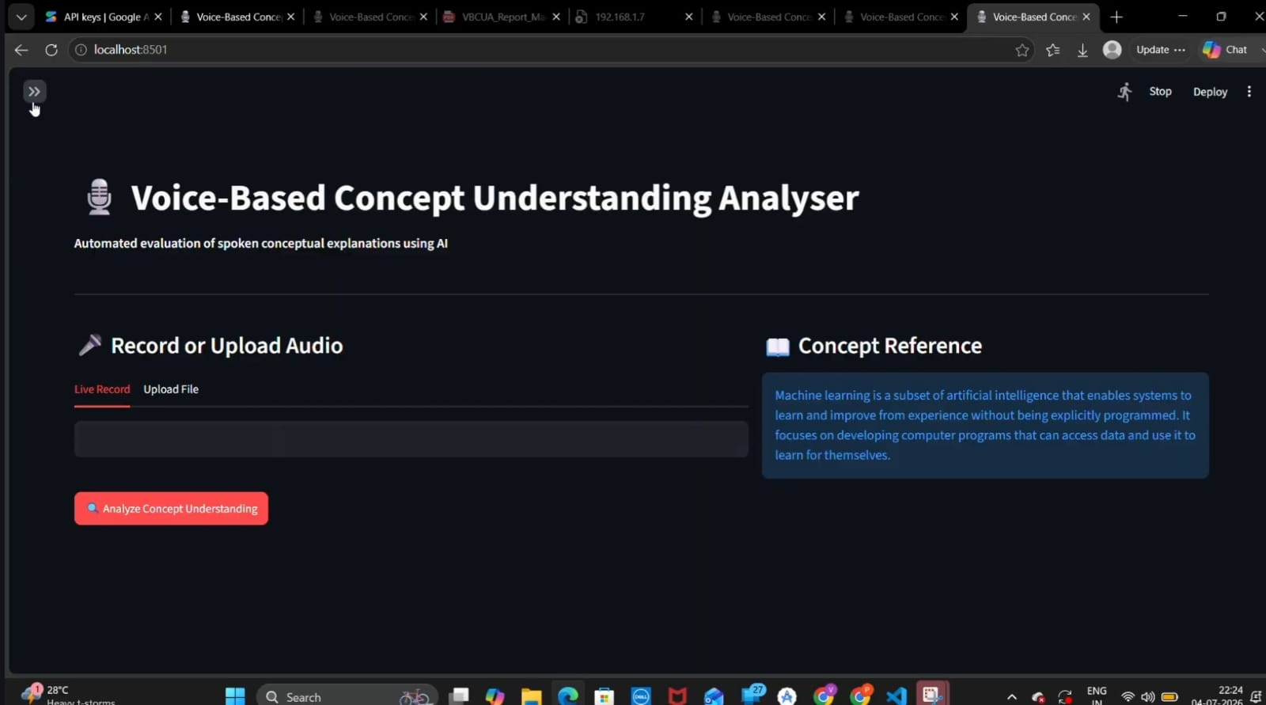
The app on first load, sidebar collapsed, Machine Learning reference shown on the right.
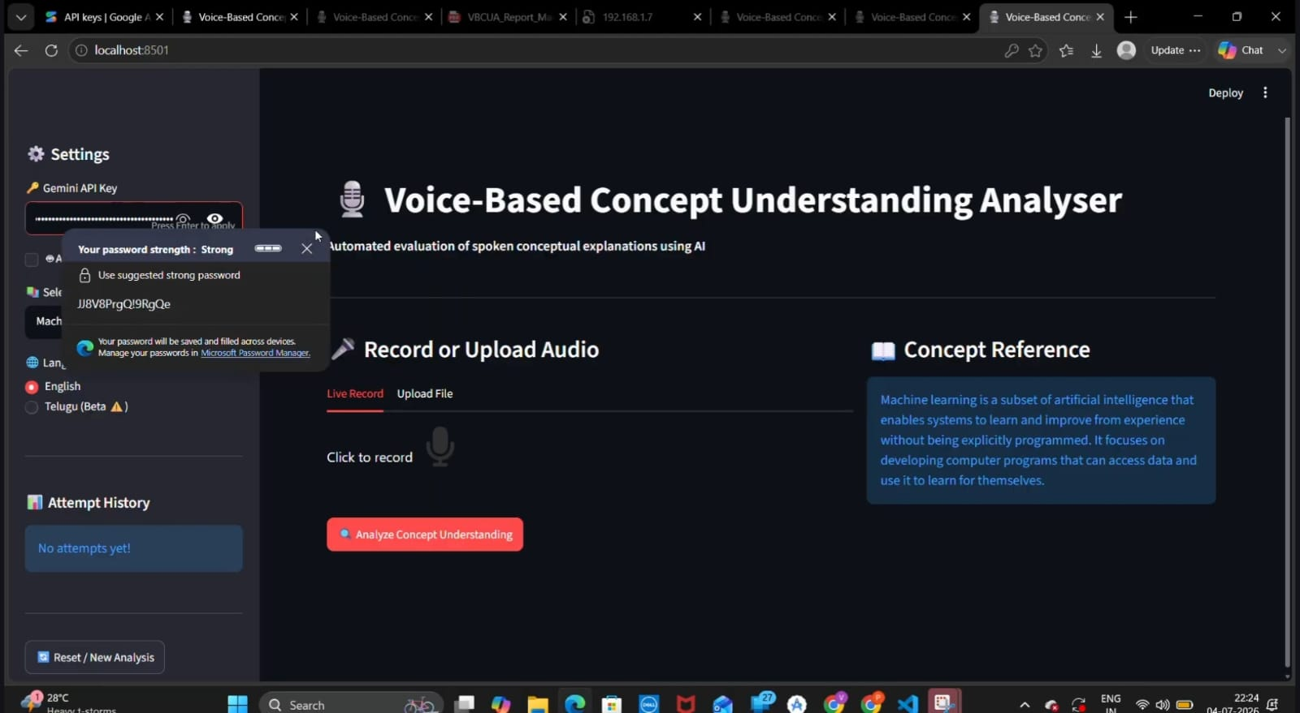
Sidebar expanded: Gemini API Key field, Language options, and an empty Attempt History.
Step 2: Selecting the Evaluation Topic
Before recording or uploading, choose how the AI should evaluate your subject material:
- Manual Selection: Click on the Select Concept Topic dropdown menu to choose from pre-configured domains, including Machine Learning, Cloud Computing, Deep Learning, Artificial Intelligence, Neural Networks, Data Science, or Natural Language Processing.
- Automated Selection: Alternatively, toggle the Auto Detect Topic (Gemini) checkbox to let the AI dynamically identify your topic from your speech context.
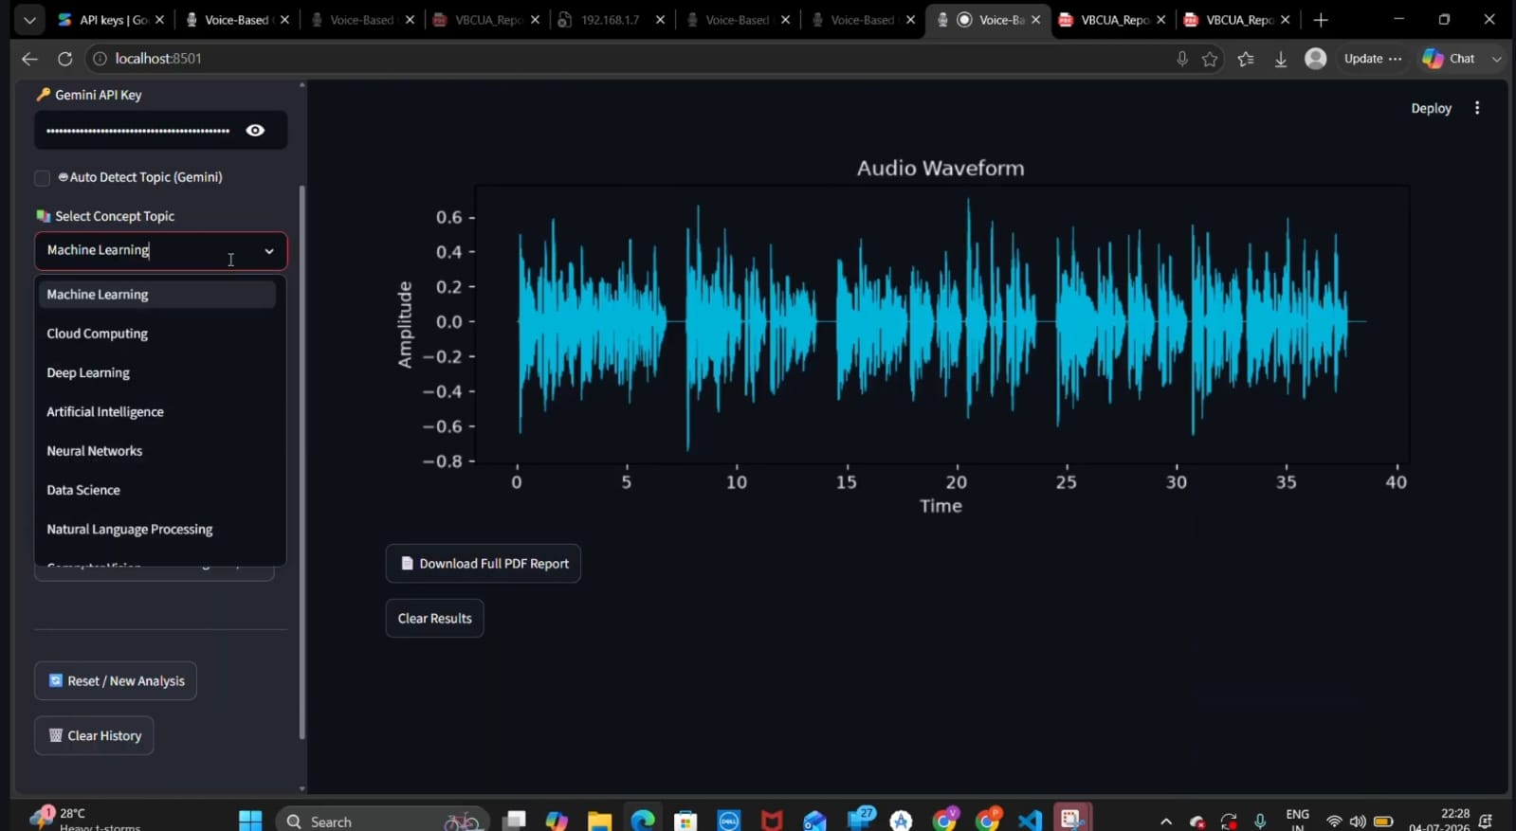
The Select Concept Topic dropdown expanded, showing all pre-configured domains.
Step 3: Providing Audio Input
You can provide your spoken conceptual explanation via two separate methods:
Option A: Live Recording
- Select the Live Record tab.
- Click the microphone icon to begin speaking your explanation directly into your system's microphone.
- Click the icon again to stop recording. A built-in audio playback bar will appear, allowing you to play back your raw recording before submission.
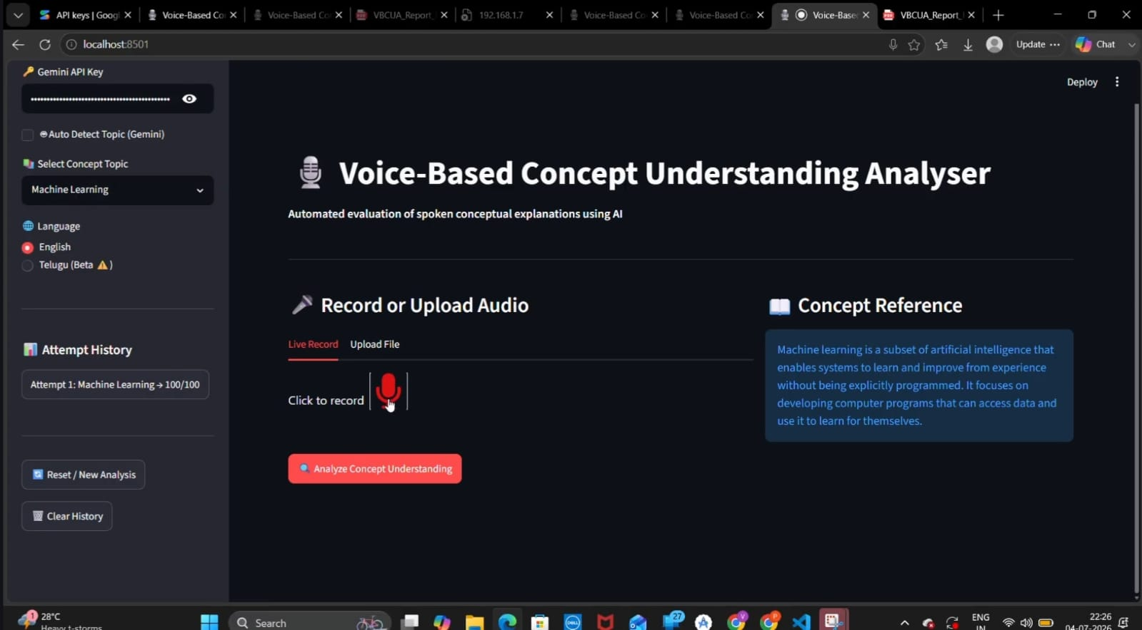
Live Record tab active, ready to capture audio from the microphone.
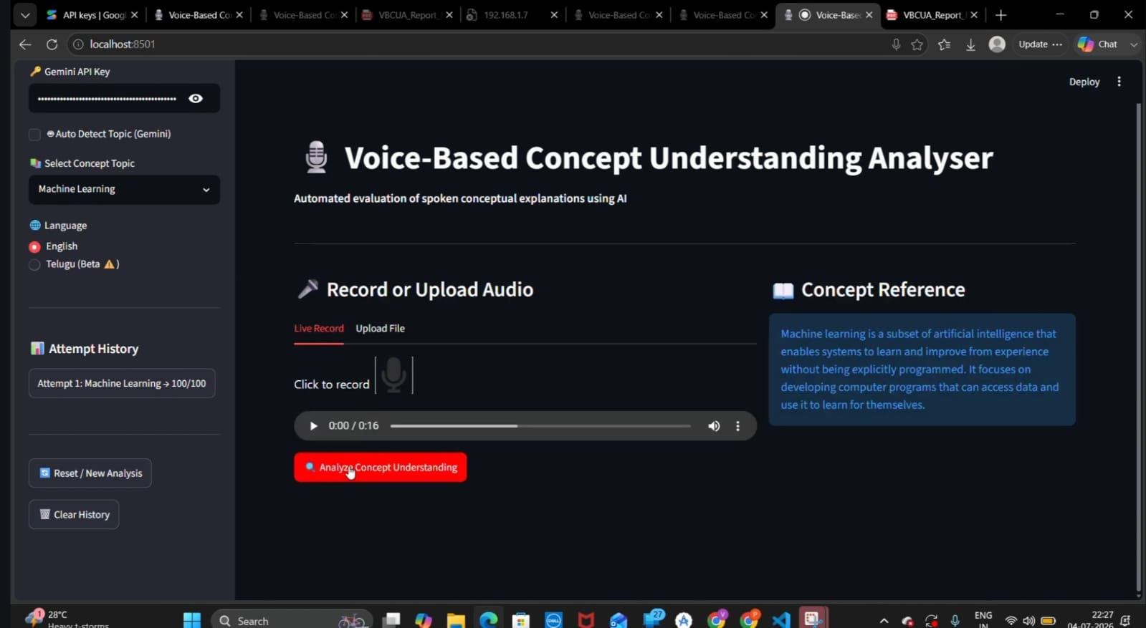
Recording captured — the inline audio playback bar (0:00 / 0:16) appears above the Analyze button.
Option B: File Upload
- Navigate to the Upload File tab under the Record or Upload Audio section.
- Click the Upload button to open your local file explorer dialog.
- Select an audio file (supporting standard formats like WAV or MP3 under 200MB) and confirm selection.
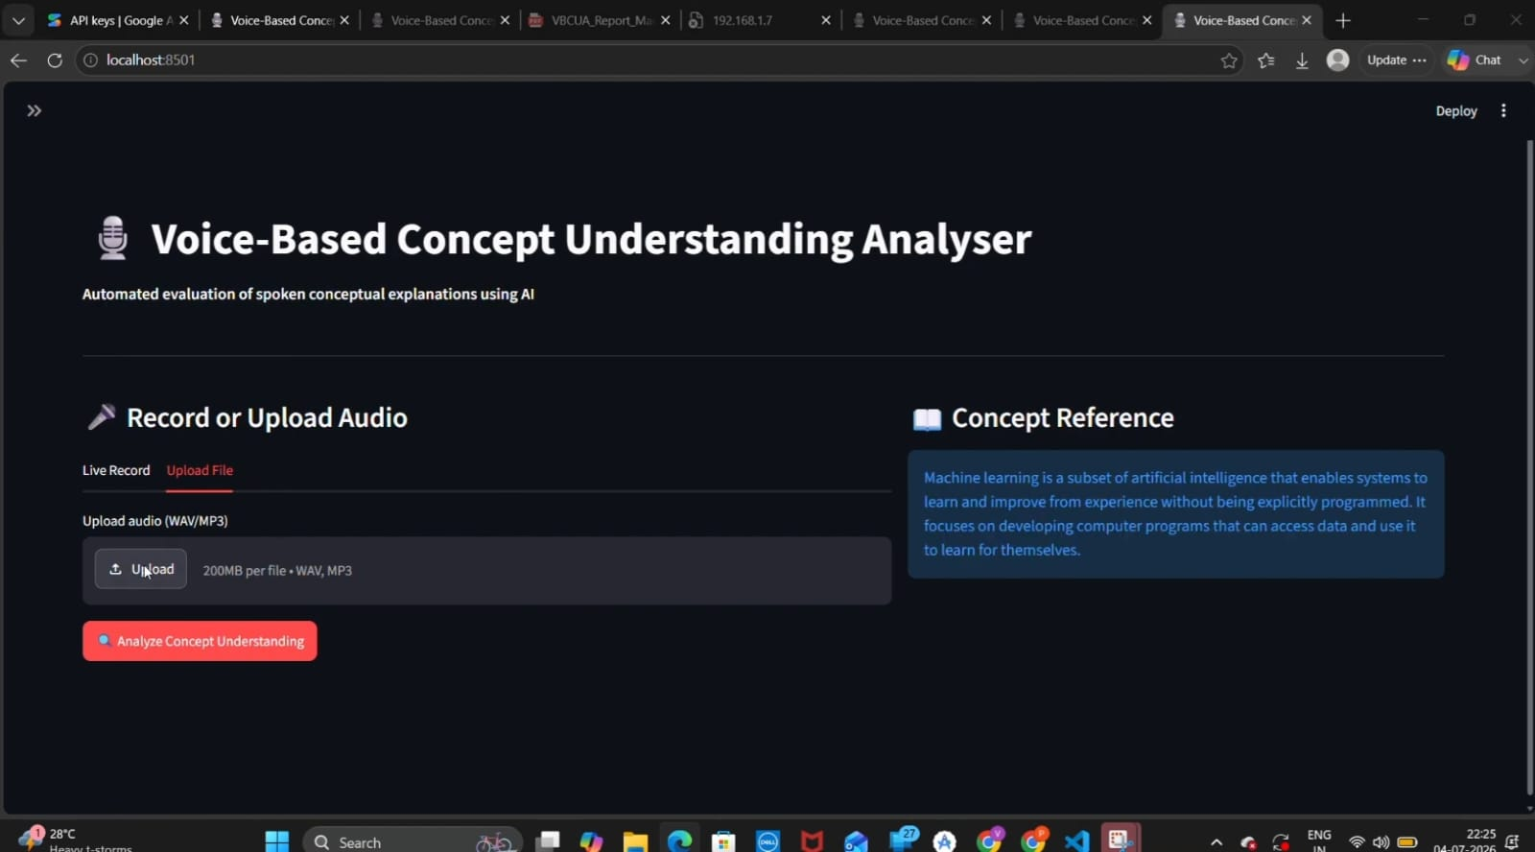
Upload File tab, showing the 200MB WAV/MP3 upload control.
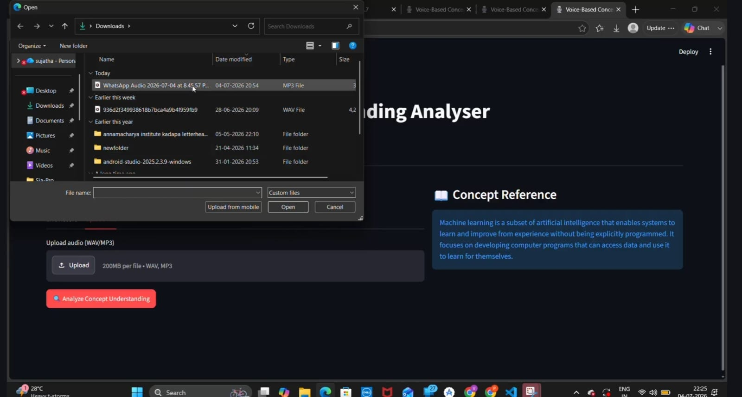
The system file explorer dialog used to select an audio file to upload.
Step 4: Running the Analysis
- Once your audio source is finalized, click the red Analyze Concept Understanding button.
- The application will display a Transcribing and evaluating... status bar while processing.
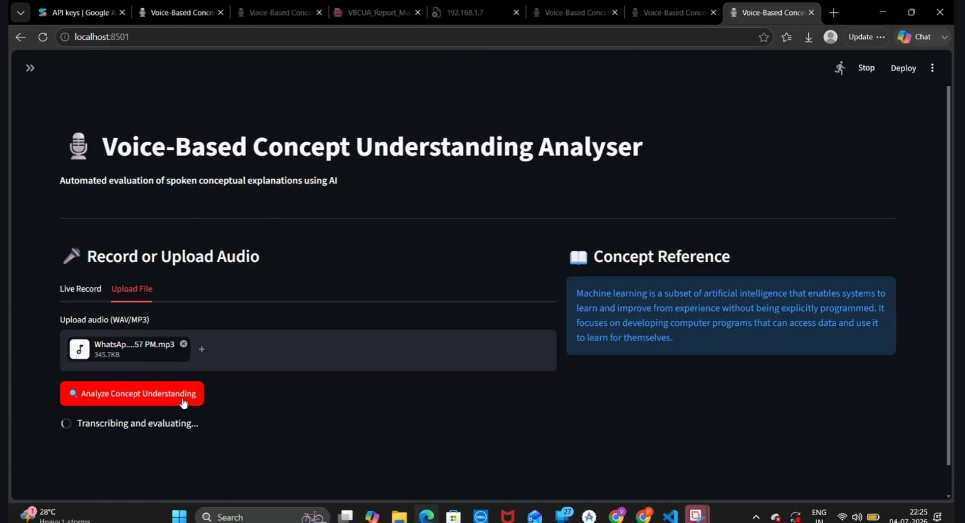
Uploaded file attached and Analyze clicked — the "Transcribing and evaluating..." status is shown.
Step 5: Reviewing Results and Metrics
- View the Analysis Results screen generated upon completion.
- Review the core metrics evaluated by the AI engine:
  - Transcribed Explanation: The full text parsed from your speech.
  - Final Score: An overall performance rating (e.g., 100/100 - Strong Understanding).
  - Semantic Similarity: Alignment accuracy between your response and the concept reference core baseline.
  - Filler Words: Total count of spoken filler terms detected.
  - Fluency Score: A performance rating measuring delivery pacing and clarity.
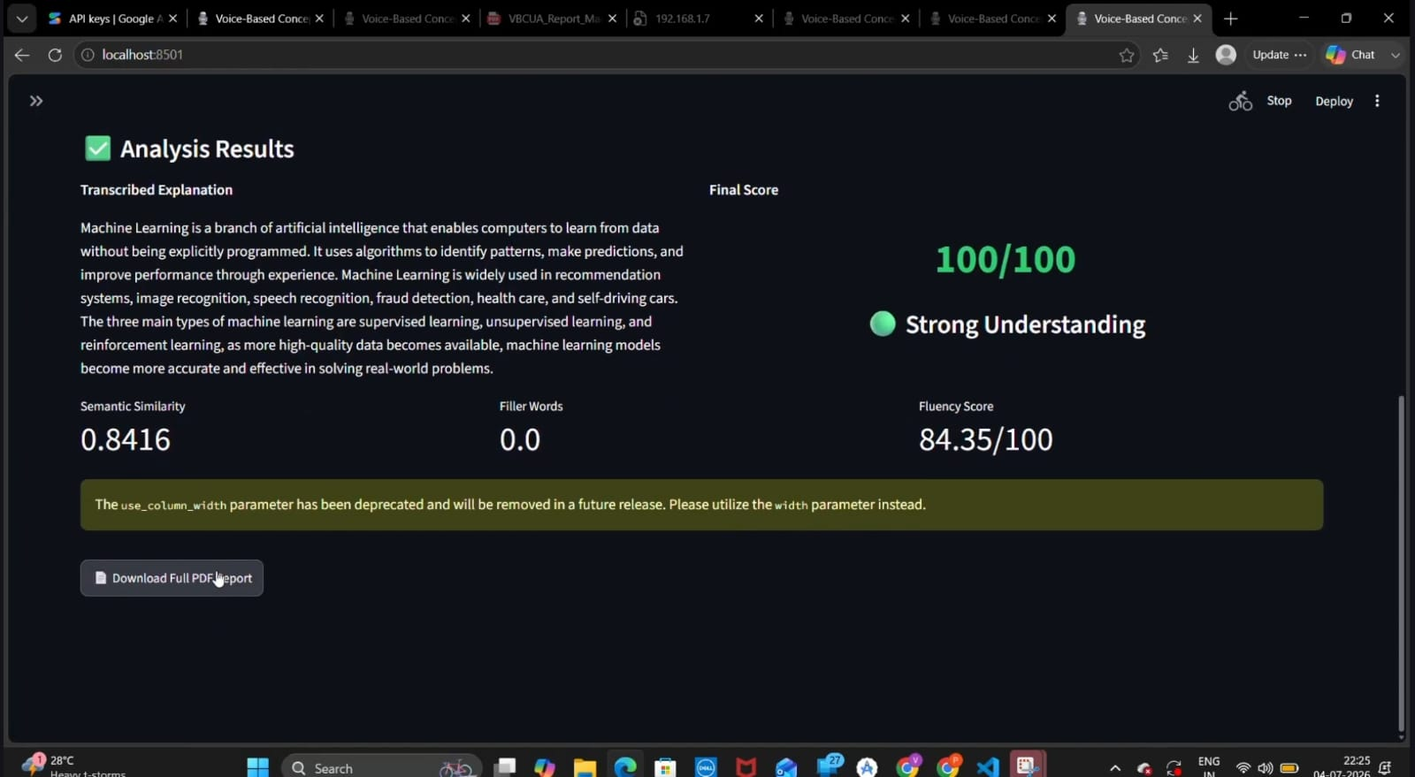
Analysis Results: Final Score 100/100 (Strong Understanding), with Semantic Similarity, Filler Words, and Fluency Score metrics.
- Scroll down to review the corresponding Audio Waveform plot measuring signal amplitude over time.
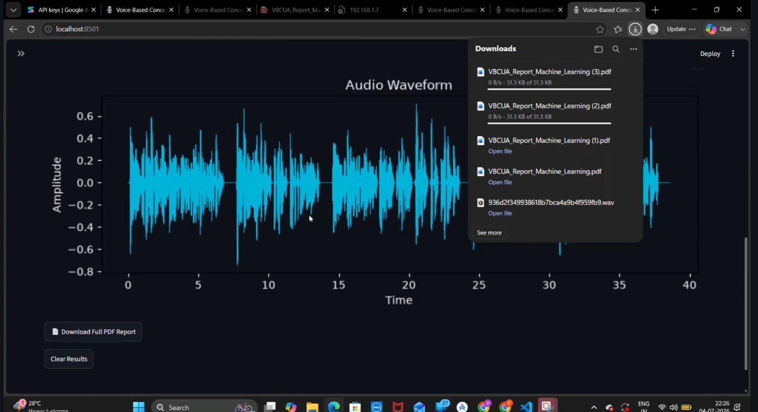
Audio Waveform plot rendered below the results, with Download Full PDF Report and Clear Results buttons.
Step 6: Exporting Reports and Tracking Progress
- Click the Download Full PDF Report button located below the results to export a structured document.
- Access the compiled evaluation sheet (e.g., VBCUA_Report_Machine_Learning.pdf) directly from your web browser's downloads manager.
- View your session history tracking log via the Attempt History panel on the lower section of the sidebar.
- To wipe parameters clean for a fresh entry, click Reset / New Analysis or wipe previous attempts using Clear History.
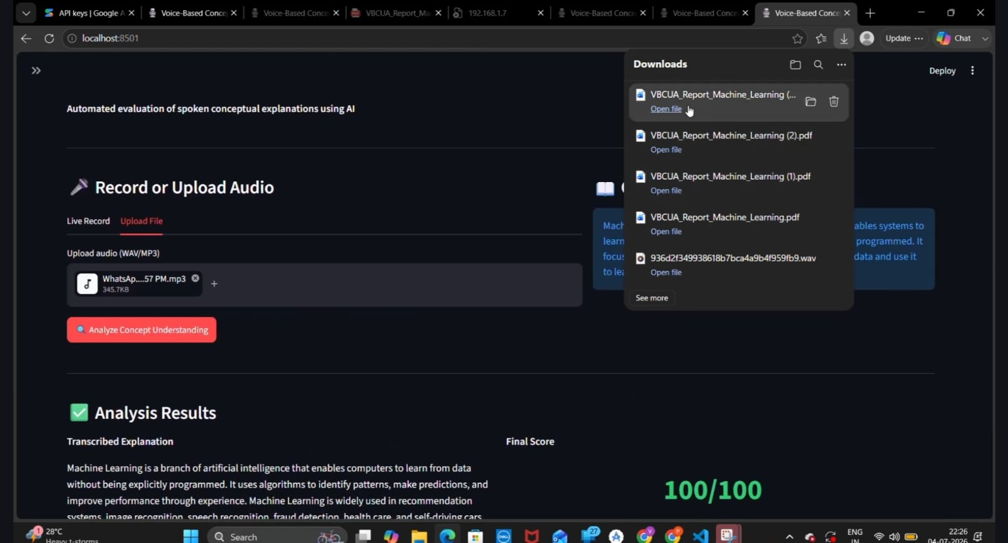
Browser downloads manager showing successive VBCUA_Report_Machine_Learning.pdf exports, each openable directly.
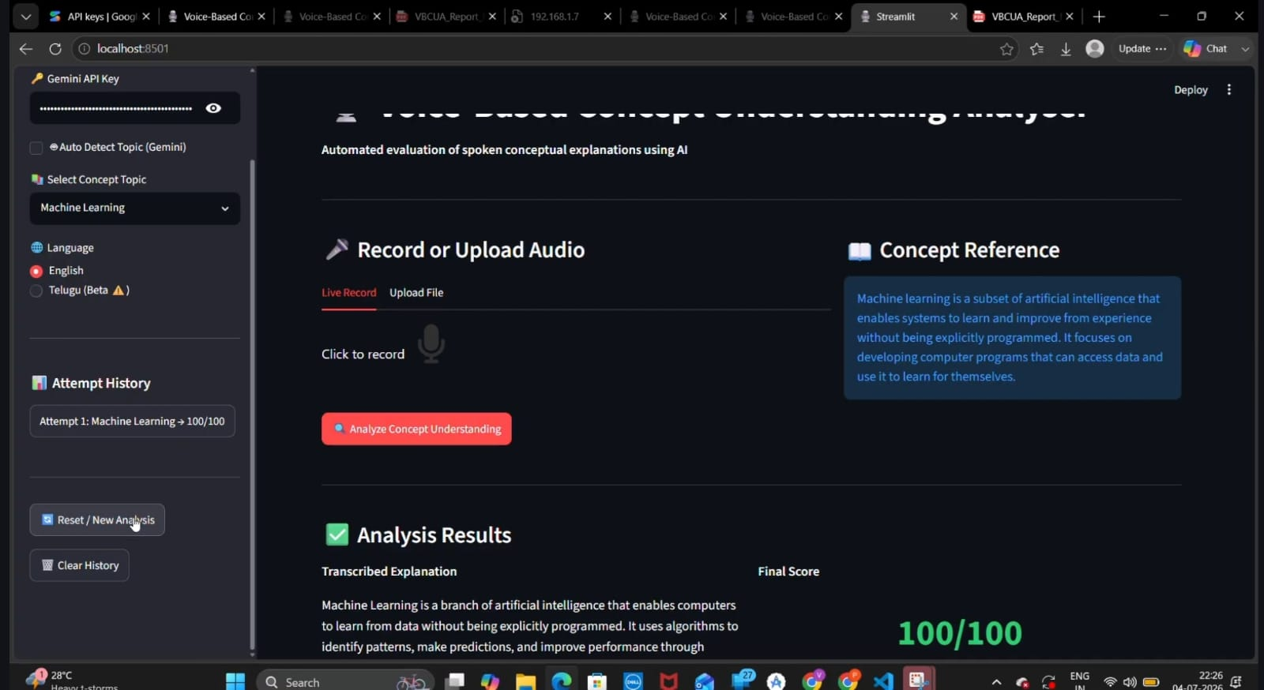
Sidebar Attempt History showing "Attempt 1: Machine Learning -> 100/100", with Reset / New Analysis and Clear History buttons.

7. Testing & Quality Assurance
The repository includes two plain, assert-based test scripts (not a pytest suite) under "6. Project Testing": test_functional.py, which checks correctness of the pure-Python helper functions, and test_performance.py, which benchmarks how fast those same functions run. Both scripts import directly from the sibling "5. Project Development Phase" folder via a relative sys.path.append and are run as standalone scripts rather than through a test runner.

7.1 Functional Tests (test_functional.py, as committed)
import sys
sys.path.append('../5. Project Development Phase')

from speech_to_text import filler_word_ratio
from scoring_engine import evaluate_understanding, calculate_fluency_score
from semantic_eval import semantic_similarity, get_reference

def test_filler_word_ratio():
text = "um this is like basically a test"
ratio = filler_word_ratio(text)
assert ratio > 0, "Filler ratio should be greater than 0"
print(f"Filler ratio test passed: {ratio}")

def test_scoring_engine():
audio = {"pause_ratio": 0.2, "rms_energy": 0.05}
score, level, color = evaluate_understanding(0.8, 0.02, audio)
assert score >= 80, "High similarity should give high score"
assert level == "Strong Understanding"
print(f"Scoring test passed: {score}/100 - {level}")

def test_poor_understanding():
audio = {"pause_ratio": 0.5, "rms_energy": 0.005}
score, level, color = evaluate_understanding(0.1, 0.2, audio)
assert level == "Poor Understanding"
print(f"Poor understanding test passed: {score}/100")

def test_semantic_similarity():
text1 = "machine learning is a subset of AI"
text2 = "machine learning enables systems to learn from data"
score = semantic_similarity(text1, text2)
assert 0 <= score <= 1, "Similarity should be between 0 and 1"
print(f"Semantic similarity test passed: {score}")

def test_fluency_score():
result = calculate_fluency_score(0.02, 0.1)
assert result["fluency_score"] >= 0
print(f"Fluency test passed: {result}")

def test_reference_exists():
ref = get_reference("Machine Learning")
assert len(ref) > 0
print("Reference test passed!")

if __name__ == "__main__":
print("Running functional tests...\n")
test_filler_word_ratio()
test_scoring_engine()
test_poor_understanding()
test_semantic_similarity()
test_fluency_score()
test_reference_exists()
print("\nAll functional tests passed!")

Run with: cd "6. Project Testing" then python test_functional.py

7.2 Performance Tests (test_performance.py, as committed)
import time
import sys
sys.path.append('../5. Project Development Phase')

from semantic_eval import semantic_similarity
from scoring_engine import evaluate_understanding, calculate_fluency_score
from speech_to_text import filler_word_ratio

def test_semantic_similarity_speed():
text1 = "Machine learning is a subset of artificial intelligence"
text2 = "ML enables systems to learn from data automatically"
start = time.time()
for _ in range(10):
semantic_similarity(text1, text2)
end = time.time()
avg_time = (end - start) / 10
assert avg_time < 2.0, f"Too slow: {avg_time:.3f}s"
print(f"Semantic similarity speed: {avg_time:.3f}s avg")

def test_scoring_speed():
audio = {"pause_ratio": 0.2, "rms_energy": 0.05}
start = time.time()
for _ in range(100):
evaluate_understanding(0.7, 0.03, audio)
end = time.time()
avg_time = (end - start) / 100
assert avg_time < 0.01
print(f"Scoring speed: {avg_time:.6f}s avg")

def test_filler_detection_speed():
text = "um like basically this is you know a test sentence uh right"
start = time.time()
for _ in range(100):
filler_word_ratio(text)
end = time.time()
avg_time = (end - start) / 100
assert avg_time < 0.01
print(f"Filler detection speed: {avg_time:.6f}s avg")

def test_fluency_calculation_speed():
start = time.time()
for _ in range(100):
calculate_fluency_score(0.03, 0.15)
end = time.time()
avg_time = (end - start) / 100
print(f"Fluency calculation speed: {avg_time:.6f}s avg")

def test_stability():
audio = {"pause_ratio": 0.2, "rms_energy": 0.05}
scores = []
for _ in range(10):
score, _, _ = evaluate_understanding(0.7, 0.03, audio)
scores.append(score)
assert len(set(scores)) == 1
print(f"Stability test passed: consistent score {scores[0]}")

if __name__ == "__main__":
print("Running performance tests...\n")
test_semantic_similarity_speed()
test_scoring_speed()
test_filler_detection_speed()
test_fluency_calculation_speed()
test_stability()
print("\nAll performance tests passed!")

Run with: cd "6. Project Testing" then python test_performance.py
What test_stability() is actually verifying: because evaluate_understanding() is a pure, deterministic function of its inputs (no randomness, no model call), calling it ten times with the same arguments must produce the exact same score every time — this test is really confirming there is no hidden non-determinism (e.g., an unseeded random component) in the rule-based scoring path, which is a valid and cheap regression guard for exactly this kind of deterministic logic.

7.3 Coverage Gaps in the Current Test Suite
Being direct about what these two scripts do not yet cover is more useful than presenting them as complete:
- No tests for speech_to_text() itself (the Whisper-calling function), extract_audio_features(), save_waveform(), auto_detect_topic(), get_gemini_feedback(), or generate_pdf_report() — all six either require audio fixtures, a Gemini API key, or file-generation assertions that the current scripts don't attempt.
- No Streamlit UI-level tests (e.g., via streamlit.testing.v1.AppTest) verifying widget wiring, session-state transitions, or the sidebar history topic-mismatch bug noted in Milestone 3.
- No tests use a real pytest runner or fixtures; both scripts rely on top-level print() statements and assert for pass/fail signaling and are invoked directly with python, which works for a quick manual check but won't integrate with CI test reporting (JUnit XML, coverage percentages, etc.) without being ported to pytest.
Suggested near-term addition (not yet in the repository): a small pytest-based test_speech_to_text.py using a short pre-recorded fixture .wav file checked into the test folder, asserting only that speech_to_text() returns success: True and a non-empty text field — this would close the biggest coverage gap (the Whisper integration path) without requiring a live Gemini key.

8. Security Considerations
As a locally run, single-user Streamlit app, the Voice-Based Concept Understanding Analyser has a small default attack surface, but the current implementation has a handful of concrete, fixable issues worth documenting plainly.

8.1 Findings Summary
Finding | Location | Risk / Impact | Recommendation
Hardcoded developer-specific filesystem path | speech_to_text.py, get_ffmpeg_path() | Low security risk, but a real portability/maintainability issue: exposes a specific local username/path structure in source control | Replace with an FFMPEG_PATH environment variable or drop the fallback entirely in favor of a clear error
Bare except: swallows all Gemini errors | semantic_eval.py, auto_detect_topic() | An invalid/expired API key, network failure, or unexpected response silently produces a wrong topic ("Machine Learning") rather than a visible error, which can mislead the user about their own analysis | Catch specific exceptions and surface a st.warning() so the user knows auto-detection failed
Gemini API key handled only in memory, per session | app.py sidebar st.text_input(type="password") | Reasonably safe by default (not written to disk, not logged) since it is never persisted, but there is also no key validation before use, so a malformed key silently triggers the same bare-except fallback above | Add a lightweight key-format check and a clear inline error message on first failed call
No audio size/duration limits before processing | app.py Analyze handler, audio_utils.py | A very large or very long upload will simply take a long time to process locally; on a constrained machine this could stall the single-threaded Streamlit session for other tabs/interactions | Add a duration check via librosa.get_duration() (or file-size check) before calling Whisper, with a clear st.error() if exceeded
Recorded-audio temp files are never cleaned up | app.py Analyze handler (recorded_path branch) | Every live recording creates a NamedTemporaryFile that is deliberately kept (so sidebar history can reference it) but is never deleted even when history is cleared or the session ends, leading to temp-directory growth over a long-running session | Track and delete stale recorded_path files when history entries referencing them are cleared, or clean up on app shutdown
No input length cap on the topic dropdown/text paths | app.py / semantic_eval.py | Low risk since topic is selected from a fixed dropdown, not freely typed, but any future free-text topic input (see Future Scope) would need explicit length/content validation before being interpolated into a Gemini prompt | Apply the same prompt-injection-aware handling used for the transcript if/when free-text topic input is added
Transcript text is interpolated directly into Gemini prompts | semantic_eval.py, auto_detect_topic() and get_gemini_feedback() | A user could speak adversarial phrasing intended to manipulate the Gemini response (e.g., asking it to output an unrelated topic or ignore the feedback instructions); since Gemini's output here only affects topic selection and free-text coaching (not the numeric score, which is rule-based), the blast radius of a successful injection is limited to cosmetic/feedback content | If this pathway is extended to affect the numeric score in the future, add the same schema-validation backstop pattern used elsewhere in this document before trusting any LLM-influenced score

8.2 What Is Already Handled Reasonably Well
- No public exposure by default: streamlit run app.py binds to localhost; there is no Ngrok tunnel or public deployment step in this repository, so the default attack surface is limited to the local machine and local network.
- The numeric score cannot be manipulated via prompt injection: because evaluate_understanding() is a pure, deterministic function over similarity/filler/pause/energy values and never calls an LLM, there is no path for adversarial transcript content to directly inflate or deflate the final 0-100 score — only the optional topic-detection and free-text feedback are LLM-influenced.
- The Gemini key is never written to disk or logged in the current code; it lives only in Streamlit's session state for the duration of the browser session, which is a reasonable default for a local single-user tool.
- File type is constrained at the uploader (type=["wav", "mp3"]), reducing (though not eliminating) the chance of a wildly unexpected file reaching Whisper/Librosa.

8.3 Recommended Hardening Before Broader Distribution
- Remove the hardcoded personal ffmpeg path and replace it with environment-variable configuration, so the repository does not implicitly disclose a specific developer's machine layout.
- Replace bare except: blocks in semantic_eval.py with specific exception handling plus visible Streamlit warnings, so failures in the optional Gemini path are never silently mistaken for a real result.
- Add basic audio duration/size validation ahead of the Whisper and Librosa calls to bound worst-case local processing time.
- If the app is ever adapted from single-user-local to a shared/hosted deployment, revisit every finding above under a multi-user threat model — in particular, the current sidebar-entered Gemini key pattern and the unbounded temp-file accumulation are acceptable for one person on one machine but would need real per-user isolation and cleanup in a shared environment.

